新概念 3 册
Lesson40 Who’s who
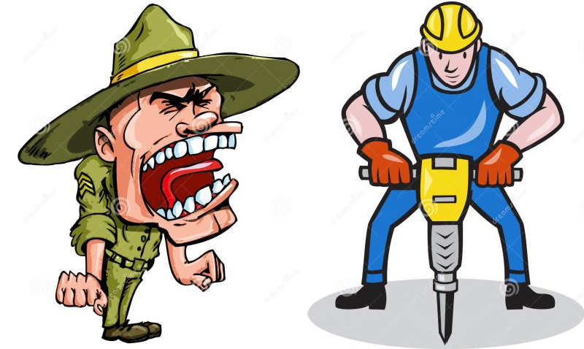

Book
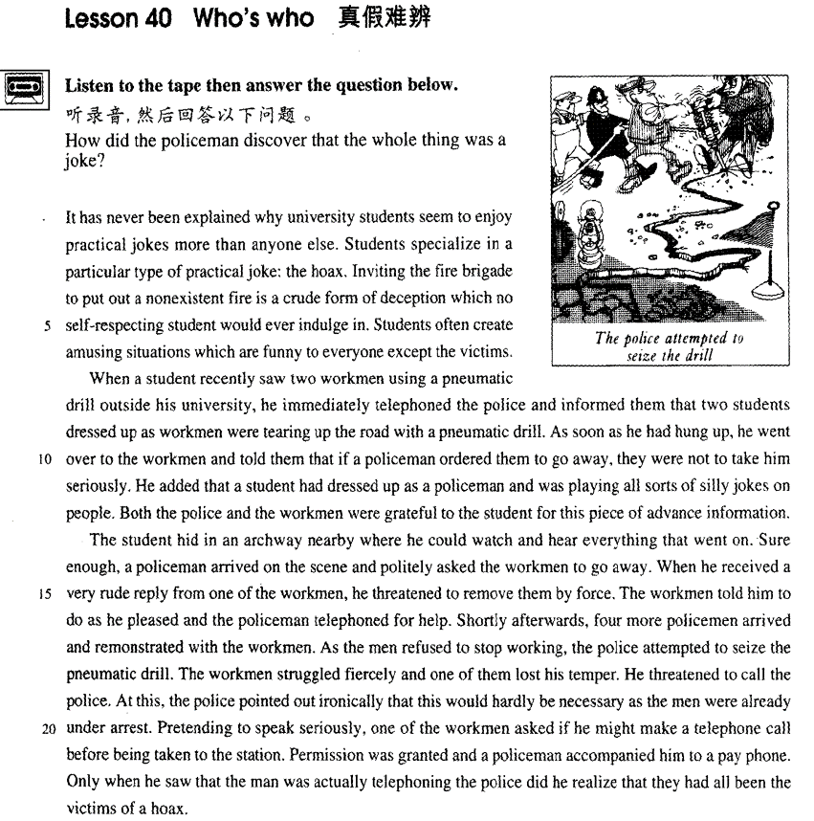

课文
It has never been explained why university students seem to enjoy practical jokes more than anyone else.
谁也弄不清为什么大学生好像比任何人都更喜欢恶作剧。

Students specialize in a particular type of practical joke: the hoax.
大学生擅长一种特殊的恶作剧--戏弄人。

Inviting the fire brigade to put out a nonexistent fire is a crude form of deception which no self-respecting student would ever indulge in.
请消防队来扑灭一场根本没有的大火是一种低级骗局，有自尊心的大学生决不会去做。

Students often create amusing situations which are funny to everyone except the victims.
大学生们常常做的是制造一种可笑的局面，使大家笑上一场，当然受害者是笑不出来的。

When a student recently saw two workmen using a pneumatic drill outside his university, he immediately telephoned the police and informed them that two students dressed up as workmen were tearing up the road with a pneumatic drill.
最近有个学生看见两个工人在学校门外用风钻干活，马上打电话报告警察，说有两个学生装扮成工人，正在用风钻破坏路面。

As soon as he had hung up, he went over to the workmen and told them that if a policeman ordered them to go away, they were not to take him seriously.
挂上电话后，他又马上来到工人那儿，告诉他们若有个警察来让他们走开，不要把他当回事，

He added that a student had dressed up as a policeman and was playing all sorts of silly jokes on people.
还对工人说，有个学生常装扮成警察无聊地同别人开玩笑。

Both the police and the workmen were grateful to the student for this piece of advance information.
警察与工人都对那个学生事先通报情况表示感谢。

The student hid in an archway nearby where he could watch and hear everything that went on.
那个学生躲在附近一拱形的门廊里，在那儿可以看见、听到现场发生的一切。

Sure enough, a policeman arrived on the scene and politely asked the workmen to go away.
果然，警察来了，不礼貌地请工人离开此地；

When he received a very rude reply from one of the workmen, he threatened to remove them by force.
但其中一个工人粗鲁地回了几句，于是警察威胁要强行使他们离开。

The workmen told him to do as he pleased and the policeman telephoned for help.
工人说，悉听尊便。警察去打电话叫人。

Shortly afterwards, 4 more policemen arrived and remonstrated with the workmen.
一会儿工夫，又来了4个警察，规劝工人离开。

As the men refused to stop working, the police attempted to seize the pneumatic drill.
由于工人拒绝停下手中的活，警察想夺风钻。

The workmen struggled fiercely and one of them lost his temper.
两个工人奋力抗争，其中一个发了火，

He threatened to call the police.
威胁说要去叫警察。

At this, the police pointed out ironically that this would hardly be necessary as the men were already under arrest.
警察听后讥讽地说，这大可不必，因为他俩已被逮捕了。

Pretending to speak seriously, one of the workmen asked if he might make a telephone call before being taken to the station.
其中一个工人装模作样地问道，在被带往警察局之前，是否可以打一个电话。

Permission was granted and a policeman accompanied him to a pay phone.
警察同意了，陪他来到一个投币地电话前，

Only when he saw that the man was actually telephoning the police did he realize that they had all been the victims of a hoax.
当他看到那个工人真的是给警察挂电话，才恍然大悟，原来他们都成一场骗局的受害者。

词汇讲解
- hoax [həʊks] n. 恶作剧（骗人相信某事）
hoax 英文解释：n. a kind of practical joke（恶作剧） in which someone makes people believe something that is not true 恶作剧（骗人相信某事）

【相关词组】
play a joke / trick on sb. 对某人恶作剧
make a fool of sb. 捉弄某人
cheat sb. out of sth. 骗走了某人某事
- He cheated the old lady out of her fortune.

trick / deceive sb. into doing 骗某人做某事
- I was tricked / deceived into believing his story.

- indulge [ɪn'dʌldʒ]v. 沉迷于……；尽情享受……
indulge in … 沉迷于……
- indulge in bad habits
- I indulged in a hot bath / an expensive dinner after a day’s hard work.

做及物动词：
indulge / spoil / pamper sb. 宠爱、娇惯某人
- I don’t agree with indulging children.
- a spoilt / pampered child 宠坏的孩子

【同根词】
indulgent adj.纵容的；放纵的
self-indulgent adj.放纵自己的；任性的

indulgence n. 沉溺；放纵；纵容
self-indulgence n.放纵自己

- advance [əd'vɑ:ns] [əd'væns] adj. 提前的（定语）
advance adj. 提前的（定语）
- advance party 先遣队
- advance notice / warning / planning 提前通知/预警/规划
- advance payment 预付款

- 走遍美国
- What a job! Good work, Richard!
- I'm so glad you like them so much.
- Like them? They represent your best work.
- Really?
- Absolutely.
- Well ... what do you think? Do I have my book?
- You do. You do.
- There’s a book here. I'll have a contract and an advance payment waiting for you, first thing in the morning.

in advance （做状语）提前的、预先的做某事
- Rent must be paid one month in advance.

in advance of … 在…之前
- Galileo’s ideas were in advance of the age in which he lived.

【同根词】
advanced adj. 高级的, 先进的
- advanced technology 先进的技术
- an elementary（基础的） / intermediate（中级的） / advanced（高级的） English course
- elementary / intermediate / advanced English learners

- remonstrate ['remənstreɪt] [rɪ'mɑ:nstreɪt] v. 抗议，规劝，告诫
remonstrate with sb. (fml.) 向某人抗议
- The coach angrily remonstrated with the referee.
- Shortly afterwards, four more policemen arrived and remonstrated with the workmen.

【扩展】
demonstrate v. 展示, 表明

【近义词组】表达“抗议”：
protest against … 聚众抗议

…… complain (to sb.) of / about sth. 抱怨/投诉
- Several people complained of cat-like noises at night and a businessman on a fishing trip saw the puma up a tree.
- Almost immediately he began to complain about the weather, for even though it was still summer, it rained continually and it was often bitterly cold.

nag sb. to do … 像某人唠叨…
- When my wife nagged me to do something about it, I told her that either I would have to buy a new mower or let the grass grow.

pester sb. to do … 纠缠某人做某事…
- From the moment he arrived there, he kept on pestering his doctor to tell him when he would be able to go home.

- ironically [aɪ'rɒnɪklɪ] adv. 讽刺地
ironically / sarcastically 讥讽地、讽刺地
- At this, the police pointed out ironically that this would hardly be necessary as the men were already under arrest.
- 'Perfume, eh?' he asked sarcastically. 'You should have declared that. Perfume is not exempt from import duty.'

【同根词】形容词
ironic / sarcastic
- I was almost there when a sarcastic voice below said, 'I don't think the windows need cleaning at this time of the night.'

【同根词】名词
irony / sarcasm
- with heavy irony / sarcasm
- 'Good of you to arrive on time,' George said, with heavy irony / sarcasm.

【扩展】
hint / trace / touch of irony / sarcasm 讽刺的味道、讽刺的成分在里面
- There was a hint of irony / sarcasm in her voice.

sarcastic 只能用于形容人的语言语气
ironic 可以形容人和事物
- the irony of fate
- It's ironic that she became a teacher ―she used to hate school.
- Ironically, his cold got better on the last day of his holiday.

课文讲解

（标题）

who’s who

who’s who 谁是谁（名字、职务等）
- 《名人录》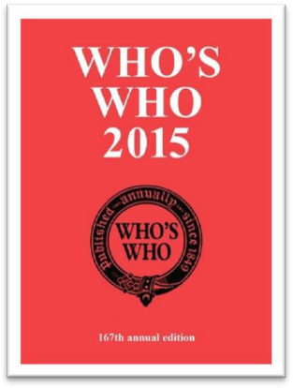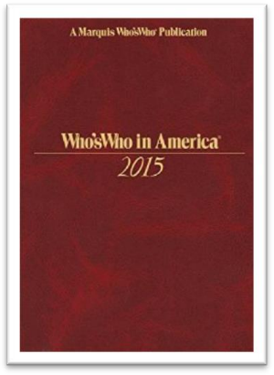
- You’ll soon get to know who’s who in the company.

which is which 分清楚谁是谁
- The twins are so alike that I can’t tell which is which.
- When Scarlet returned to the farm, the old maidservant began to tell her who married whom, who had what children and so on.

（第一段）

It has never been explained why university students seem to enjoy practical jokes more than anyone else.

语法分析：
It（形式主语） has never been explained why university students seem to enjoy practical jokes more than anyone else（比较状语). （why...主语从句）

知识点（1）
写作：地道表达

表达“谁也无法解释”：
nobody can explain why … （中式英语）
it has never been explained why … （地道表达，重点突出）
- 造句：谁也无法解释玛雅 (Maya) 文明为什么会突然从地球上消失 (vanish)。

- It has never been explained why Maya civilization vanished from the earth.

【扩展1】
表达“我无法理解”：
表达①：
I can’t understand / explain why … （中式英语）

表达②：地道表达
why … is beyond me 我无法理解
- Why people are prepared to tolerate a four-hour journey each day for the dubious privilege of living in the country is beyond me.
- 造句：我无法理解Jane 为什么愿意 (be prepared to do) 嫁给这样一个懒汉 (lazy-bones)。
- Why Jane was prepared to marry such a lazy-bones is beyond me.

表达③：地道表达
it has always been a mystery to me why … 我无法理解
- It has always been a mystery to me why city dwellers, who appreciate all these things, obstinately pretend that they would prefer to live in the country.
- 造句：我一直搞不懂 John 为什么偏要假装 (obstinately pretend) 喜欢古典乐 (classical music)。
- It has always been a mystery to me why John obstinately pretends that he would prefer classical music.

- 听力真题：
A．She's not sure how she was able to finish so early.
B．She wasn't able to manage the project well.
C．She's not sure how to solve the mystery.
D．She still hasn't heard what was shocking.
- M: I was shocked when I heard you'd finished your research project a whole month early.
- W: How I managed to do it is still a mystery to me.
- Q: What does the woman mean?
- Answer: (A) She's not sure how she was able to finish so early.

【扩展2】
表达“人们对某事有争议”：
表达①：
People still have different opinions about whether … （中式英语）

表达②：
whether … is a moot point at present
- Whether the whole universe does so is a moot point at present.
- 造句：人们对是否建造更多公路会减少交通堵塞 (traffic congestion) 尚有争议。
- Whether building more roads reduces traffic congestion is a moot point at present.

知识点（2） 【课文仿写】
- 造句：谁也无法解释为什么住在地中海地区的人看似比任何人都更爱吃章鱼 (octopus)。
- It has never been explained why people who live in the Mediterranean seem to enjoy eating octopus more than anyone else.

Students specialize in a particular type of practical joke: the hoax.

知识点（1）
specialize in … 专门研究……

specialized adj. 专业的……
- specialized knowledge 专业知识
- specialized labour / labor 专业工人

- So great is our passion for doing things for ourselves, that we are becoming increasingly less dependent on specialized labour.

知识点（2）
语法：如果把表示类型的词放在前面，如sort、kind、type，后面的可数名词可以当不可数名词；如果把表示类型的词放在后面，可数名词放在前面时一般用复数

- a particular type of practical joke
- practical jokes of a particular type

- The more expensive kind of antique shop（单数） where rare objects are beautifully displayed in glass cases to keep them free from dust is（单数） usually a forbidding place.
- Antique shops（复数） of the more expensive kind where rare objects are beautifully displayed in glass cases to keep them free from dust are（复数） usually forbidding places.

Inviting the fire brigade to put out a nonexistent fire is a crude form of deception which no self-respecting student would ever indulge in.

语法分析：
Inviting the fire brigade to put out a non-existent fire（动名词做主语） is a crude form of deception（名词表语） which no self-respecting student would ever indulge in（which...定语从句）.

知识点（1）
put out = extinguish 熄灭、扑灭（不强调方式）
- put out / extinguish the fire / cigarette / light

smother 压灭（强调方式）
quench 用水浇灭（强调方式）
blow out 吹灭（强调方式）

知识点（2）
crude 冒犯的，粗俗的，粗鲁的
- However, boxing was very crude, for there were no rules and a prize-fighter could be seriously injured or even killed during a match.

知识点（3）
form n. a type of sth. form of … 类型、种类
- a severe form of cancer
- different forms of government

知识点（4）
no = not any（后面一般跟单数）没有任何一个
self-respecting （一般用在否定句中）有自尊心的

no self-respecting … would do sth. 没有自尊心的…会做…
- No self-respecting doctor would refuse to treat a sick person.
- No self-respecting government would yield to terrorists.

知识点（5）【课文仿写】
- 造句：考试中作弊是一种很不光彩的行为 (disgraceful behavior)，任何有自尊的学生都不会去做。
- Cheating in examinations is disgraceful behavior which no self-respecting student would ever indulge in.

Students often create amusing situations which are funny to everyone except the victims.

课文替换：
- Students often create funny situations which are amusing to / amuse everyone except the victims.

（第二段）

When a student recently saw two workmen using a pneumatic drill outside his university, he immediately telephoned the police and informed them that two students dressed up as workmen were tearing up the road with a pneumatic drill.

语法分析：
When a student recently saw two workmen using a pneumatic drill outside his university（分词短语；固定搭配，see sb. doing sth） （When... 时间状语）, he immediately telephoned the police and informed them that two students dressed up as workmen（非谓语动词、分词做后置定语）were tearing up the road with a pneumatic drill. （that… 宾语从句）

知识点（1）
telephone the police 打电话报警

- He told him he had better return it or he would call the police.
- At first, she decided to go to the police, but …

- 课后题：
- Mrs. Ramsay was not to inform the police （通知警方，不强调方式）and had to pay ₤1,000.

知识点（2） 复习
inform sb. of sth. 通知某人某事
inform sb. that ...

convince sb. of sth. 使某人相信某事
convince sb. that ...

remind sb. of sth. 使某人回忆起某事
remind sb. that ...

warn sb. of sth. 警告某人某事
warn sb. that ...

assure sb. of sth. 让某人对某事放心
assure sb. that ...

知识点（3） Lesson13
dress (sb.) up as ... 打扮成
- She intended to dress up as a ghost ...
- He added that a student had dressed up as a policeman …
- They dressed him up as a gorilla.

disguise sb. as ... 把某人装扮成…
- 课后题：Lesson4
- 2．What did Alfred Bloggs do for over two years? C
(a) He told his wife he worked for the Corporation, when in fact he did not.
(b) He disguised himself as a dustman.
(c) He led a double life.
(d) He earned twice as much as he used to.

- He disguised himself as a dustman.

disguised as ...（非谓语）装扮成了…模样
- Alfred the Great acted as his own spy, visiting Danish camps disguised as a minstrel.

- 课文写法替换：
- ... two students disguised as workmen were tearing up the road with a pneumatic drill.

知识点（4）
tear up sth. 1.开凿路面；2.撕碎
- The plumbers tore up the road（开凿路面） to lay a new water main.
- He tore up （撕碎）the letter with anger.

tear 撕扯
- The child’s misery tore my heart.

tear sth. in half / two 把某事一撕两半
tear sth. to pieces 把某事撕成碎片

tear sth. away 把某事撕掉
- In August, she was struck by a very heavy storm during which her rudder was torn away.

As soon as he had hung up, he went over to the workmen and told them that if a policeman ordered them to go away, they were not to take him seriously.

语法分析：
As soon as he had hung up（时间状语从句）, he went over to the workmen and told them that if a policeman ordered them to go away（条件状语从句）, they were not to take him seriously. （that… 宾语从句）

知识点（1）复习、总结
【相关词组】引导时间状语，表达“刚一…就…”：
as soon as ...

immediately / directly ... （充当连词）

the moment ... （充当连词）

on / upon ...

no sooner ... than ... no sooner（副词短语，先发生） ... than（连词，后发生） ...

hardly / barely / scarcely ... when / before ... hardly / barely / scarcely否定词放在句首要部分倒装

- 课文写法替换：
- Immediately / Directly he had hung up, ...
- The moment he had hung up,
- ... On / Upon hanging up, ...
- He had no sooner hung up than he went over to ...
- No sooner had he hung up than he went over to ...
- He had hardly hung up when he went over to ...
- Hardly had he hung up when he went over to ...

知识点（2） Lesson33
hang up 挂电话
- You hang up hurriedly and attend to baby, crockery, etc.

put the phone down 挂电话
slam the phone down 生气的挂电话
get cut off 断线了

- 托福听力真题：
A．Eating in a cafeteria.
B．Buying something in a store.
C．Talking on the telephone.
D．Getting money at a bank.
- M: Did you get cut off?
- W: No, they asked me to hang up and try again later.
- Q: What has the woman been doing?
- Answer: (C) Talking on the telephone.

知识点（3）
he went over to …
over 表示个跨度，从那边到这边
- He’s seen me! He’s coming over!

- 托福听力真题：
A．She wants to check the weather before deciding.
B．She has a problem with her hearing.
C．She’d enjoy coming to dinner another time.
D．She wants the man to help her with some work.
- M: Can you come over for dinner tonight?
- W: I’m up to my ears in work, so I’ll have to take a rain check.
- Q: What does the woman mean?
- Answer: (C) She’d enjoy coming to dinner another time.
- 走遍美国:：
- Hello. This is Richard Stewart. My wife, Marilyn Stewart, is a member of your program. I’d like to come to the ten o’clock advanced class this morning.
- Oh, fine, fine. Be here a few minutes early. You need to complete some forms before the class.
- Thanks. I’m on my way over. Good-bye.
- Bye-bye.

知识点（4）
…they were not to take（应该） him seriously.

语法：be to do (fml.) 的四种用法
用法①： 打算
- I’m to see her tomorrow.

用法②：命令
- You’re to be back by 10 o’clock.
- No one is to leave the building.

用法③：能够
- How am I to pay such a debt?
- We are not to be bullied.

用法④：应该
- Such men are to be pitied rather than despised.
- Some books are to be tasted, others to be swallowed, and some few to be chewed and digested. — Francis Bacon

He added that a student had dressed up as a policeman and was playing all sorts of silly jokes on people.

语法分析：
He added that a student had dressed up as a policeman and was playing all sorts of silly jokes on people. （that… 宾语从句）
知识点（1） 复习、总结
add v. 补充说
- Then I added with a smile, ‘It’s a strange mixture I make myself.’

threaten 威胁说
- When he received a very rude reply from one of the workmen, he threatened to remove them by force.

point out 提醒说
- At this, the police pointed out ironically that this would hardly be necessary as the men were already under arrest.

claim 声称说
- However, as the evidence began to accumulate, experts from the Zoo felt obliged to investigate, for the descriptions given by people who claimed to have seen the puma were extraordinarily similar.

confirm 证实说
- It immediately ran away when she saw it, and experts confirmed that a puma will not attack a human being unless it is cornered.

complain 抱怨说
- Several people complained of ‘cat-like noises’ at night and a businessman on a fishing trip saw the puma up a tree.

put it 措辞说
- …, as one of them put it ‘ate like kings’.
- I don’t know how to put it.

state 声明说
- The writer stated that Rastus was in safe hands …

explain 解释说
- She explained that Rastus was very dear to her.

mumble 自言自语说
- He was still mumbling (mumble) something about hospitals at the end of the party when he slipped on a piece of ice and broke his left leg.

nag 唠叨说
- When my wife nagged me to do something about it, I told her that either I would have to buy a new mower or let the grass grow.

知识点（2） 复习
play a joke / trick on sb. 开某人玩笑
- One night, the gaoler decided to play a joke on his colleague to find out if, after so many performances, he had managed to learn the contents of the letter by heart.

知识点（3）
all sorts / kinds / types of sth. 各种各样的
- She has to deal with all kinds of complaints.

Both the police and the workmen were grateful to the student for this piece of advance information.

知识点（1）Lesson15
be thankful / grateful / obliged / indebted to sb. for sth. 因为某事感谢某人

- I’m thankful to you for your help.
- I’m much grateful to you for your advice.
- I’m deeply obliged to you for your encouragement.
- I’m most indebted to you for this piece of advance information.

【相关词组】
I appreciate your help / it.
I owe you (one).

（第三段）

The student hid in an archway nearby where he could watch and hear everything that went on.

语法分析：
The student hid in an archway nearby where he could watch and hear everything that went on（that...定语从句）. （where...定语从句）

知识点（1）复习
 archway 拱道；拱门

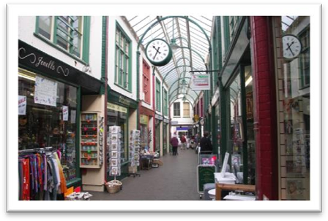arcade

 17-Arch Bridge

 Arch of Triumph

知识点（2）
- … an archway nearby … （nearby副词）
- a nearby archway （nearby 形容词）
- a near archway ☓（near不能做“距离”前置定语）
- The archway is very near. （near做表语）

- in the near future （near做前置定语，形容“时间”上的近）
- a near relative （near做前置定语，形容“关系”上的近）

知识点（3） 复习
语法：定语从句充当并列句
- The monks prefer winter to summer for they have more privacy.

- 造句：我的暑假是在乡下度过的，在那儿我可以更不受打扰地生活。
- I spent my summer vacation in the country where I had more privacy.

Sure enough, a policeman arrived on the scene and politely asked the workmen to go away.

知识点（1） 复习
sure enough 果然
- Sure enough, Rastus arrived punctually at seven o'clock that evening.

知识点（2）
on the scene / spot 在现场，到现场
- Meanwhile, two other actors, Rockwall Slinger and Merlin Greeves, had carried two large food baskets to a shady spot under some trees.

on the spot 当场……, 立即……
- He would invent fanciful names on the spot.

When he received a very rude reply from one of the workmen, he threatened to remove them by force.

知识点（1） 复习
receive + n. 受到了……; 得到了……; 遭到了……
- These young people, who love the peace of mountains, always receive a warm welcome at St. Bernard's monastery.
- No creature has received more praise and abuse than the common garden snail.
- This exhibition received a great deal of attention in the press, for though the pictures were supposed to be the work of famous artists, they had in fact been painted by Dickie.
- The majority of the patients attending the medical out-patients departments of our hospitals feel that they have not received adequate treatment unless they are able to carry home with them some tangible remedy in the shape of a bottle of medicine, a box of pills, or a small jar of ointment, …

- receive support 得到支持
- receive good education 收到好的教育
- receive a heavy blow 遭到重击
- receive a serious injury 受到严重伤害

知识点（2）
threaten to do 1. 威胁说……；2.有……的危险
- We keep trying all four methods, but the sheer volume of rubbish we produce worldwide threatens to overwhelm （有……的危险）us.

The workmen told him to do as he pleased and the policeman telephoned for help.

语法分析：
The workmen told him to do as he pleased（方式状语）（ and the policeman telephoned for help.

知识点（1）
please v.高兴, 乐意
- Come whenever you please.

Shortly afterwards, 4 more policemen arrived and remonstrated with the workmen.

shortly afterwards 不久之后

remonstrate 规劝

As the men refused to stop working, the police attempted to seize the pneumatic drill.

The workmen struggled fiercely and one of them lost his temper.

lose one’s temper 发火了

【反义】
keep one’s temper 忍住不发脾气

He threatened to call the police.

At this, the police pointed out ironically that this would hardly be necessary as the men were already under arrest.

语法分析：
At this（介词短语做状语）, the police pointed out ironically（副词做状语） that this would hardly be necessary as the men were already under arrest（原因状语从句). （that… 宾语从句）

知识点（1）
语法：在英语中，this 和 that 均可前指，但一般只有 this 可以后指。
- He threatened to call the police. At this（前指）, the police pointed out ironically that …
- Finding that he could not remember a word of the letter either, the gaoler replied: 'The light is indeed dim, sire. I must get my glasses.' With this（前指）, he hurried off the stage.

- To be, or not to be: that（前指） is the question. — Shakespeare
- Good friends, good books and a sleepy conscience: this （前指）is the ideal life. — Mark Twain
- Of all men's miseries the bitterest is this（后指）: to know so much and to have control over nothing. — Herodotus

知识点（2）
point out 指出，提醒说
- Franz poured scorn on the idea, pointing out that his brother had been killed in action during the war.

知识点（3）
be under arrest 被捕

be under + n. 处于某状态
- The car is under repair. 在修理之中
- The castle is under attack. 在遭受攻击之中
- The subject is under discussion. 在讨论之中
- The matter is under consideration. 在考虑之中
- The patient is under observation. 在观察之中
- The case is under investigation. 在调查之中
- The bridge is under construction. 在建造之中
- The building is under renovation. 在整修之中

Pretending to speak seriously, one of the workmen asked if he might make a telephone call before being taken to the station.

语法分析：
Pretending to speak seriously（非谓语动词作状语), one of the workmen asked if he might make a telephone call before（介词） being taken to the station. （if… 宾语从句）

知识点（1） Lesson4
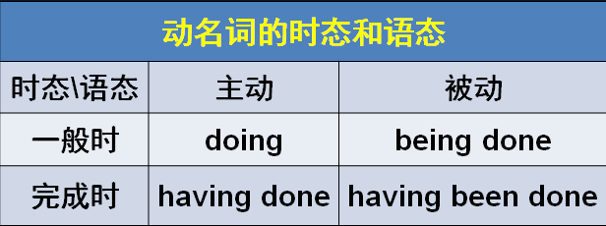

Permission was granted and a policeman accompanied him to a pay phone.

知识点（1）
give / grant (sb.) permission 给某人许可
refuse / deny (sb.) permission 拒绝请求

- The police granted him permission and a policeman … （不地道，不简洁）

- 造句：他问老师他是否能打个电话。老师不允许他这么做，于是他只好等到下课。
- He asked the teacher if he might make a telephone call. Permission was denied and he had to wait until the class was over.

知识点（2）
pay phone / pay station 公共电话

Only when he saw that the man was actually telephoning the police did he realize that they had all been the victims of a hoax.

语法分析：
Only when he saw that the man was actually telephoning the police （when...时间状语从句） did (only+状语位于句首，后面句子要部分倒装) he realize that they had all been the victims of a hoax. （that… 宾语从句）

知识点（1）Lesson5
only +状语 翻译为“只有、仅有”；如果是时间状语翻译为“直到”
语法：复习“only + 状语”位于句首，用部分倒装

- Only（直到） then did he realize that he was mistaken.
- Only（只有） by working hard can we succeed in doing anything.
- Only（直到） after a baby seal is pushed into the sea by its mother will it learn how to swim.
- Only（直到） when he saw that the man was actually telephoning the police did he realize that they had all been the victims of a hoax.

